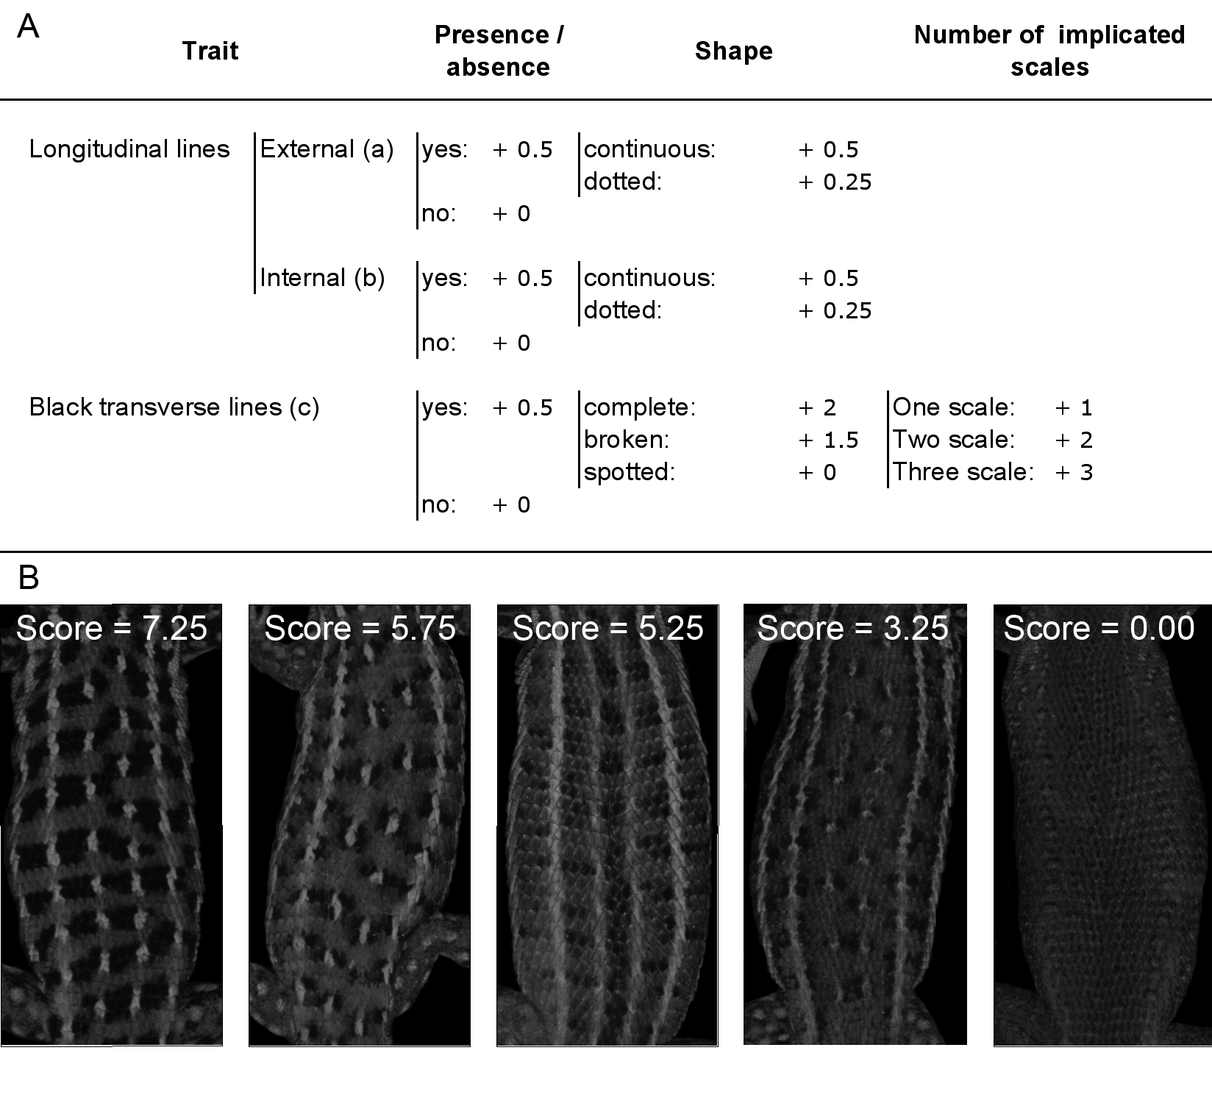
Fig. S2. Dorsal pattern index. A. Classification of the index. Classification starts with the presence or absence of longitudinal and transversal lines, followed by a classification of their shape and thickness. Numbers refer to the scores that need to be added up for each of the present categories, in order to obtain the final dorsal pattern index. B. Most frequent discrete dorsal designs of the Spanish Sand Racer and their pattern index.

